**EXPERIMENT NO:8**

Fifo page replacement:

#include < stdio.h >

**int** main()

{

**int** incomingStream[] = {4 , 1 , 2 , 4 , 5};

**int** pageFaults = 0;

**int** frames = 3;

**int** m, n, s, pages;

    pages = **sizeof**(incomingStream)/**sizeof**(incomingStream[0]);

    printf(" Incoming \ t Frame 1 \ t Frame 2 \ t Frame 3 ");

**int** temp[ frames ];

**for**(m = 0; m < frames; m++)

    {

        temp[m] = -1;

    }

**for**(m = 0; m < pages; m++)

    {

        s = 0;

**for**(n = 0; n < frames; n++)

        {

**if**(incomingStream[m] == temp[n])

            {

                s++;

             pageFaults--;

            }

        }

        pageFaults++;

**if**((pageFaults <= frames) && (s == 0))

        {

            temp[m] = incomingStream[m];

        }          **else** **if**(s == 0)

        {

           temp[(pageFaults - 1) % frames] = incomingStream[m];

        }

        printf("\n");

        printf("%d\t\t\t",incomingStream[m]);

**for**(n = 0; n < frames; n++)

        {

**if**(temp[n] != -1)

                printf(" %d\t\t\t", temp[n]);

**else**

                printf(" - \t\t\t");

        }

    }

    printf("\nTotal Page Faults:\t%d\n", pageFaults);

**return** 0;

}

**OUTPUT:**

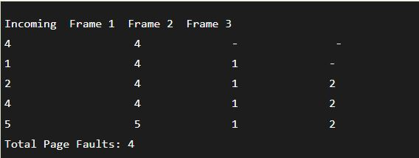

**LRU page replacement:**

#include<stdio.h>

#include<conio.h>

void main()

{

int i, j , k, min, rs[25], m[10], count[10], flag[25], n, f, pf=0, next=1;

printf("Enter the length of reference string -- ");

scanf("%d",&n);

printf("Enter the reference string -- ");

for(i=0;i<n;i++)

{

scanf("%d",&rs[i]);

flag[i]=0;

}

printf("Enter the number of frames -- ");

scanf("%d",&f);

for(i=0;i<f;i++)

{

count[i]=0;

m[i]=-1;

}

printf("\nThe Page Replacement process is -- \n");

for(i=0;i<n;i++)

{

for(j=0;j<f;j++)

{

if(m[j]==rs[i])

{

flag[i]=1;

count[j]=next;

next++;

}

}

if(flag[i]==0)

{

if(i<f)

{ m[i]=rs[i];

count[i]=next;

next++;

}

else

{ min=0;

for(j=1;j<f;j++)

if(count[min] > count[j])

min=j;

m[min]=rs[i];

count[min]=next;

next++;

}

pf++;

}

for(j=0;j<f;j++)

printf("%d\t", m[j]);

if(flag[i]==0)

printf("PF No. -- %d" , pf);

printf("\n");

}

printf("\nThe number of page faults using LRU are %d",pf);

getch();

}

**OUTPUT:**

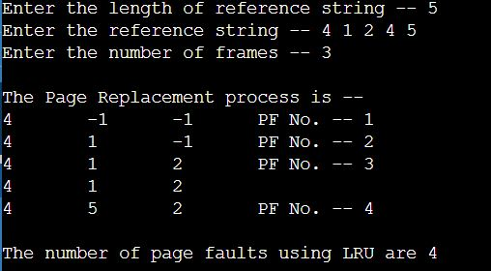

**Optimal page replacement:**

#include<stdio.h>

int main()

{

int no_of_frames, no_of_pages, frames[10], pages[30], temp[10], flag1, flag2, flag3, i, j, k, pos, max, faults = 0;

printf("Enter number of frames: ");

scanf("%d", &no_of_frames);

printf("Enter number of pages: ");

scanf("%d", &no_of_pages);

printf("Enter page reference string: ");

for(i = 0; i < no_of_pages; ++i){

scanf("%d", &pages[i]);

}

for(i = 0; i < no_of_frames; ++i){

frames[i] = -1;

}

for(i = 0; i < no_of_pages; ++i){

flag1 = flag2 = 0;

for(j = 0; j < no_of_frames; ++j){

if(frames[j] == pages[i]){

flag1 = flag2 = 1;

break;

}

}

if(flag1 == 0){

for(j = 0; j < no_of_frames; ++j){

if(frames[j] == -1){

faults++;

frames[j] = pages[i];

flag2 = 1;

break;

}

}

}

if(flag2 == 0){

flag3 =0;

for(j = 0; j < no_of_frames; ++j){

temp[j] = -1;

for(k = i + 1; k < no_of_pages; ++k){

if(frames[j] == pages[k]){

temp[j] = k;

break;

}

}

}

for(j = 0; j < no_of_frames; ++j){

if(temp[j] == -1){

pos = j;

flag3 = 1;

break;

}

}

if(flag3 ==0){

max = temp[0];

pos = 0;

for(j = 1; j < no_of_frames; ++j){

if(temp[j] > max){

max = temp[j];

pos = j;

}

}

}

frames[pos] = pages[i];

faults++;

}

printf("\n");

for(j = 0; j < no_of_frames; ++j){

printf("%d\t", frames[j]);

}

}

printf("\n\nTotal Page Faults = %d", faults);

return 0;

}

**OUTPUT:**

